**DAILY ONLINE ACTIVITIES SUMMARY**

|  |  |  |  |  |  |  |  |  |
| --- | --- | --- | --- | --- | --- | --- | --- | --- |
| **Date:** | 09-06-2020 | | | | | **Name:** | Chethan C K | |
| **Sem & Sec** | Fourth sem section A | | | | | **USN:** | 4AL18CS017 | |
| **Online Test Summary** | | | | | | | | |
| **Subject** | | N/A | | | | | | |
| **Max. Marks** | | N/A | | **Score** | | | N/A | |
| **Certification Course Summary** | | | | | | | | |
| **Course** | **Facial recognition using python** | | | | | | | |
| **Certificate Provider** | | | Udemy | | **Duration** | | | 3 hr |
| **Coding Challenges** | | | | | | | | |
| **Problem Statement:**  1: [Write](https://github.com/orgs/alvas-education-foundation/teams/2nd-year/discussions/107) a c++ program to rotate the given matrix. | | | | | | | | |
| **Status:** completed | | | | | | | | |
| **Uploaded the report in Github** | | | | | yes | | | |
| **If yes Repository name** | | | | | <https://github.com/alvas-education-foundation/chethan_c_k> | | | |
| **Uploaded the report in slack** | | | | | yes | | | |

**Online Test Details: N/A**

**Online Course Details:**

1. Name of course: **Facial recognition using python**

Certificate provider: Udemy

Today I had learned about real time facial expression detection.

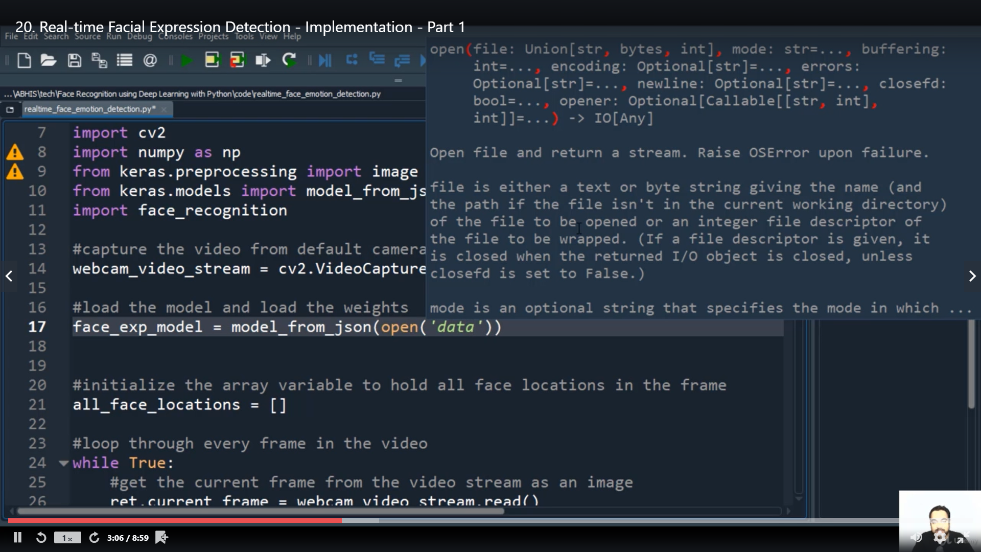

**Online coding:**

Problem 1: (using c++) Write a c++ program to rotate a matrix.

